How to Use PVCS Tracker

- Purpose

The purpose of using PVCS (Professional Version Control System) Tracker is to capture, manage, and communicate changes regarding present applications, products and/or requests for future releases. It also provides basic process control, coordination within and across groups, environments, and tools. Note: It can work along with PVCS Version Manager.

- Benefits

There are several benefits from using PVCS Tracker. First, it is possible to easily identify critical issues for any/all of the SmartForce development tools. Second, it affords the accurate capture and maintenance of issues instead of relying on email to communicate issues and changes. Third, it is possible to create reports to identify areas for improvement in the various software and product development processes. Fourth, it helps to insure that all work is tracked along with the associated Project Plans. Finally, it will allow SmartForce to set Quality Assurance goals and identify future training needs.

- User ID

To submit a finding into PVCS Tracker, the user needs to have an Account. An account is set up by sending an email to: Rhoda_bryce@SmartForce.com. All User IDs are the first letter of the first name followed by the last name, up to 9 characters.

Roles and responsibilities for each person are defined by the PVCS Tracker Administrator and associated with the User ID. This will determine what the user sees and what is accomplished in Tracker. The Learning Development Manager, the QA Manager, the Media Manager, and the Tech Development Manager will determine views and privileges.

User IDs are specific to a project. The User will only see projects he/she has access to in PVCS Tracker.

- Privileges

Privileges are assigned to users as a method of maintaining or managing different databases. Your assigned group will determine what you can do and what you cannot do within a project database. If you are unable to perform a certain task, this is probably the reason.

The different groups are:
Submitter
Support Engineer
Developer Engineer
Quality Engineer
Manager
Public - which everyone belongs to
administrator - - Tracker Administrator (Rhoda)
user - - all members of development team

- Login

  - Open the browser.
  - Type in the following URL: http://10.4.68.49.
  - Click on the PVCS Tracker link.

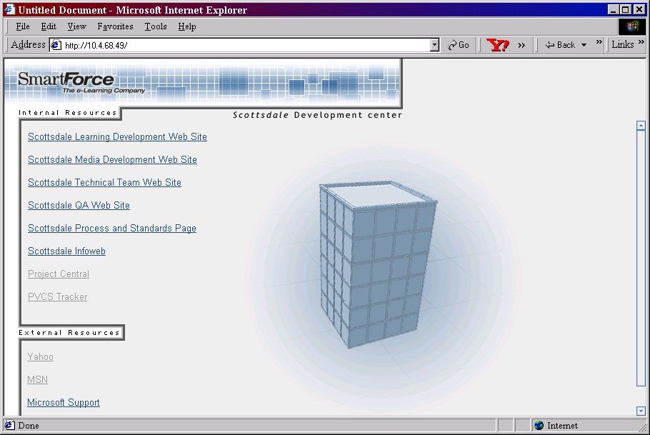

  - Or type in the address field: http://10.4.68.49/trackbin/wtms.dll.
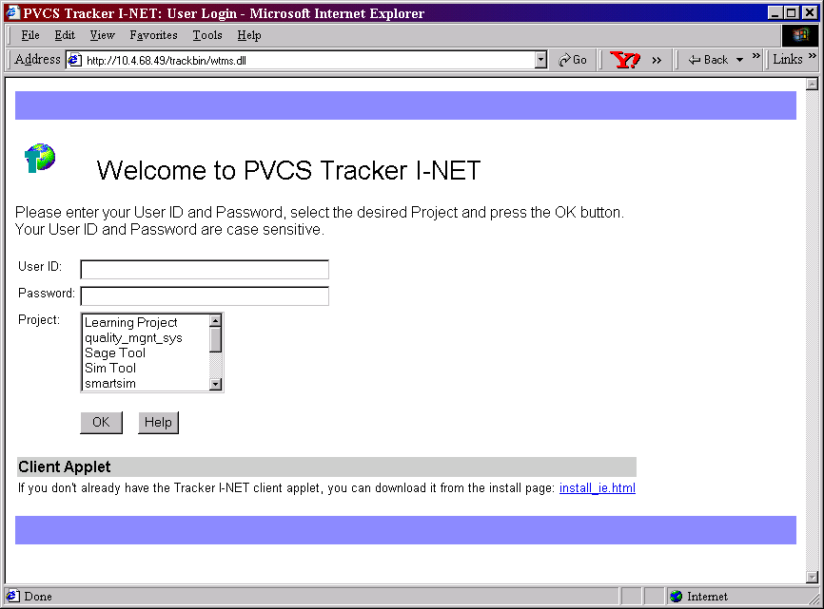
  - Type in User ID. Example: rbryce
  - Type in Password Initial: password
  - Select a project to which a software change request (SCR) should be submitted.

Current Project choices include (as of 1/21/02):

- Learning Project - visible but no database actually exists
- PVCS Tracker - issues with PVCS Tracker are reported in this project (submit available for all users)
- quality_mgmt_sys - issues with process and quality manuals are reported in this project. (submit available for all users)
- Sage Tool - issues with the Sage Tool are reported in this project
- Sim Tool - issues with xNet Workbench are reported in this project
- smartsim - runtime and sim-specific issues are reported in this project (submit available for all users)
- systems architecture - issues with SmartForce servers are reported in this project (submit available for all users)
- Thick Client Platform - issues with the user environment for learning object development tools are reported in this project (submit available for all users)
- Training - project for practicing entering smartsim issues
- Web Learning Project - visible but no database actually exists
- xNet26a - visible but no database actually exists

  - Click OK when finished.

Note: The client applet may need to be installed on first use. Select the install_ie.html link to install the applet.

- Changing the Password

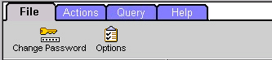

  - To change the password, select the Change Password icon. A new window will appear.

  - Enter the password in the Current Password field.
  - Enter a unique name in the New Password field using a maximum of 35 alphanumeric characters.
  - Confirm the new password by re-entering it in the Confirm Password field.
  - Click OK to activate the new password.
  - If the password is incorrect, choose Cancel to close the window without changing the password

Note: If the user cannot change the password, contact the Tracker Administrator.

- Different Views of SCRs

There are three main views a user will come across while in PVCS Tracker.

  - Quick View

The quick view provides a summary of all the SCRs for a particular project. This will be the first view the user will see upon entering a specific project. In this example, the smartsim project is used. The name of the project is highlighted on the left side of the partitioned screen (with a computer hard drive icon) and it is also visible at the top of the right side of the partitioned screen.
  - Summary View

The summary view is used at the query level. This view provides a user an overview for SCRs pertaining to a specific query. It provides the title of the SCR (usually a brief description of the issue), an indication whether there is a note or file attached, and to whom the SCR is assigned. In this example, the All_SCRs query is used. Queries can also be found in the other folders: InTray, Personal Queries, and Temporary Queries (which is not visible in this example).
  - Detailed View

The detailed view is used at the individual SCR level. This view gives the user a more in-depth view of a particular SCR. It includes a description field along with the history of the SCR (not seen in this picture).

Note: When in the summary view, the user cannot view attached files or notes until the user selects Update File or Update Notes. In some cases, depending on the user's privileges, this option is not available.

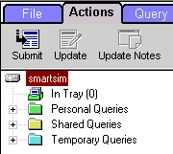
- SCRs Locations

  - In Tray

SCRs within the In Tray are sent by other project team members. The default for this area are those issues that have been assigned to the user.

  - Personal Queries

Personal queries are saved to the user's local hard drive and can only be viewed by the user. They are strictly for personal use.

  - Shared Queries

Shared queries are saved on the web server and can be seen by anyone in the project. There are a number of default queries already initiated.

  - Temporary Queries

A new or edited query is held in memory as a temporary query until it is saved to a specific name or the user exits PVCS Tracker. The program only allows one temporary query at a time.

- Submitting an SCR

  - Login to the project to which an SCR will be submitted.
  - This view should reflect the current project name chosen earlier in this document. The ACTIONS tab should be highlighted also.

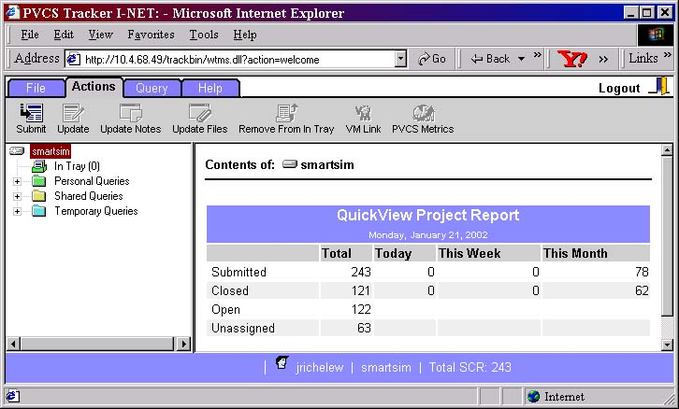
  - A list of existing SCRs for this project is shown in the right window.
  - To Submit an SCR, click on the Submit Icon in the tool bar, the one all the way to the left.
  - A Submit SCR window will appear.

Note: Please refer to the appendix for each database project format.

- Updating an SCR

  - Updates are limited to specific persons and privileges, so this may not be an option for every user. It is not possible to update an SCR until it has a specific identifier or SCR issue number.
  - From the In Tray page (in this example), select the SCR to be updated by checking the box in the right window next to the SCR to be updated. A user can also update an SCR from the other query folders - this also depends on privileges.

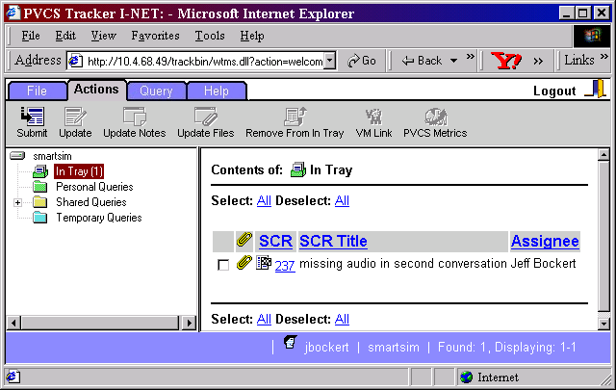
  - After selecting a SCR, the remainder of the icons on the tool bar becomes visible.

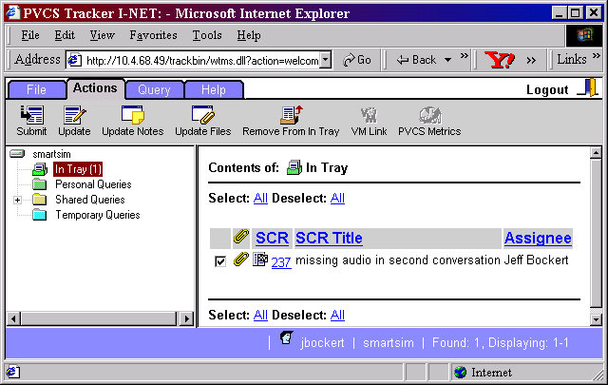
  - Click Update on the File Tab.
  - Complete the Update SCR form. Please refer to the appendices for the respective Update SCR format.

Note: There is no limit on the number of times an SCR can be modified until it is closed. However, only certain users access the information.

- Adding Notes

Notes are a valuable part of the SCR process. Notes provide the researcher, developer, and tester with valuable information including: (1) a means to explain the problem further; (2) a way to update the SCR with additional research information; (3) a way to update the SCR with resolution notes (the most important) and various other uses.

  - Display the issue in the Update page by:
(1) Placing a check in the box next to the issue to be updated in the In Tray
(2) Choosing a radio button next to an issue in a query results page; or
(3) Clicking an issue number in either the In Tray.

  - Choose Update Notes from the Actions tab. The Add Notes window will appear.

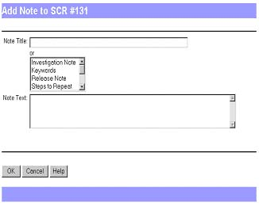

  - Enter the note title in the Note Title field or choose from the list of pre-created note titles from the scrollable box. Note: It is easier to select one of the pre-created titles if it is relevant for note.
  - Enter the text of the note in the Note Text field.
  - After filling out the note form, click OK to add the note to the issue.
  - If the information is not correct, click Cancel to return all fields to their original values and start writing the note again.

Note: There is a 30-32K size limit (around 350 words) to the Notes section.

- Adding /Editing/Deleting Notes Already in the SCR

  - Display the issue in the Update page by:
(1) Placing a check in the box next to the issue to be updated in the In Tray;
(2) Choosing a radio button next to an issue in a query results page; or
(3) Clicking an issue number in either the In Tray or a query results page.
  - Choose Update Notes from the Actions tab. The Add, Edit, and Delete radio buttons will be displayed

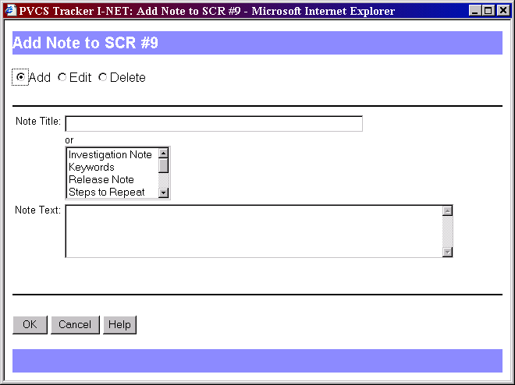
To add another note:

  - Select the Add radio button and either enter the note title in the Note Title field or choose from the list of different titles.
  - After filling out the rest of the note form, click OK to add the note to the issue.
  - If the information is not correct, click Cancel to return all fields to their original values and start writing the note again.

To edit a note already saved:

  - Select the Edit radio button and select the note that you would like to edit.

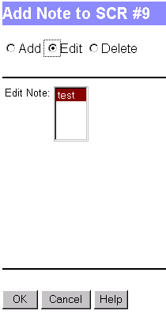
  - After selecting the specific edit note to be edited from the Edit Note field, click OK to make the necessary changes.

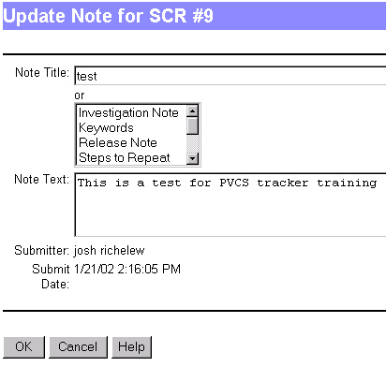
  - Click OK to save your changes.
To delete a note:

  - Select the Delete radio button and choose the note to be deleted.

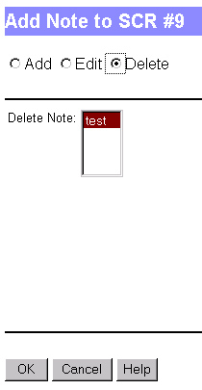
  - After selecting the note to be deleted, click OK. The note has now been deleted.

Note: Once a note is deleted, it is unrecoverable. Use this functionality wisely.
- Adding Files

Files attached to an SCR provide concrete data that the issue exists. Files can also be used to help in the verification process (a series of steps). Therefore, before any files are can be added to an SCR, print screens, transcripts, or any other data must be saved into a Word document. Note: There is not a limit to the number of files that can be attached to an SCR.

  - From an open issue, click Update Files at the top of the Actions tab. The Attach File window appears.

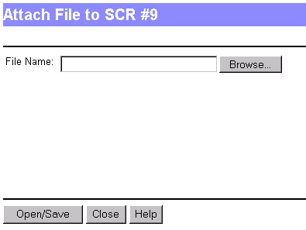
  - If the user knows the actual name and path where document can be found, this can be put directly into the File Name field. Otherwise, it is suggested that the user browse for the document.
  - When the user has identified the correct document, click the Attach button. A message will appear confirming that the document has been processed.

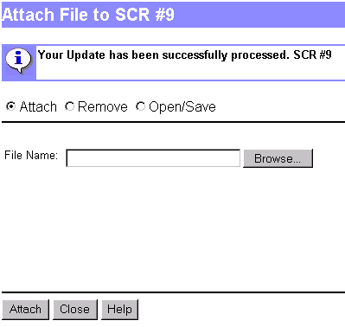
  - To add another file, repeat steps 13.1 - 13.3; otherwise, click Close.

- Removing Files

  - From an open issue, click Update Files at the top of the Actions tab. The Attach File window appears.

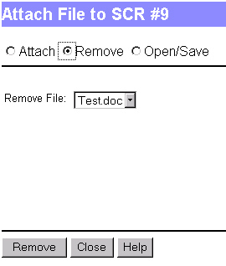
  - Select the Remove radio button.
  - Choose the name of the file to be removed from the Remove File list.
  - Click Remove. The note has now been deleted.

Note: Once you remove a file, it is unrecoverable. Use this functionality wisely.

- Viewing Files

  - From an open issue, click Update Files at the top of the Actions tab. The Attach File window appears.

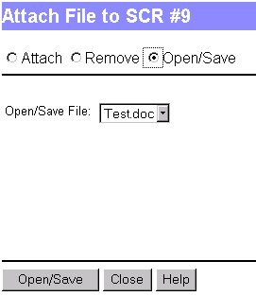
  - Choose the name of the file from the Open/Save File list.
  - Click Open/Save. The note will automatically open in another window
  - When finished, close the new document window, and then click Close on the Attach File window.

- Updating/Editing Files

The procedure for Updating/Editing attached files resembles the procedure for Viewing Files (Steps15.1 -15.4). However, there are a few differences.

  - After viewing and modifying the attached file, select Save As from the application's file menu (most often this will be Microsoft Word). The file should be named slightly different from the original (possibly include date and time of revision at the end of title). Note: This saves the new document to the user's hard drive. Make sure you know the location of the revised file.
  - Follow steps 13.1 - 13.3, to attach the revised file.
  - Remove the old version by following steps 14.1-14.3.

Note: It is possible to include a note instead of going through this process. However, notes can only include text. Therefore, if the addition requires a graphical representation, the update/edit file procedure should be used.
- Removing SCRs From the In Tray

  - Display the issue by:
(1) Placing a check in the box next to the issue to be updated in the In Tray.
(2) Choosing a radio button next to an issue in a query results page.
(3) Clicking an issue number in either the In Tray or a query results page.

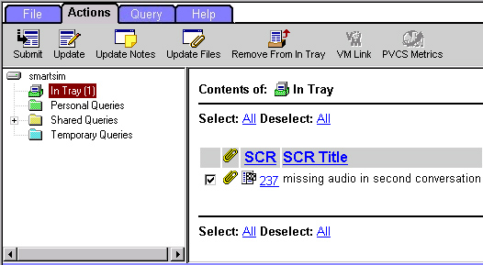

  - Click the Remove from Tray icon on the Action Tab.
  - The SCR should disappear upon refresh.

Note: When deleting issues from the In Tray, they are hidden from view but are not deleted from the database.

- Queries

Queries allow users a means to find issues that match a specific set of search criteria. Because there may be many SCRs in a particular project a user can quickly isolate those issues he/she are responsible for, have submitted, etc.

Note: There are many predefined queries in PVCS Tracker. If the list of queries do not meet the user's needs, custom queries can be created.

- Creating Custom Queries

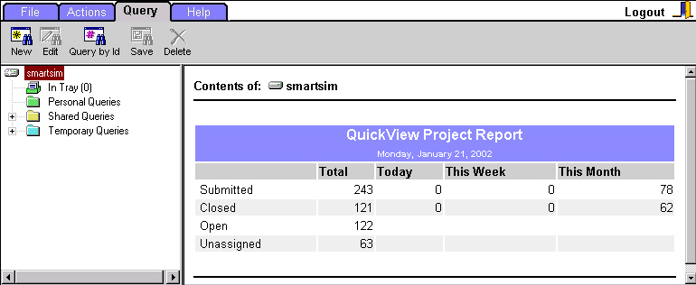
  - Select the New icon on the Query tab. The Build Custom Query window appears.

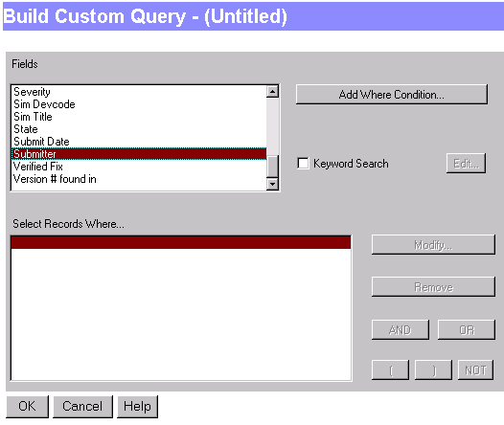

  - Highlight any of the options in the Fields section. (Ex. For this example, the Submitter option has been chosen).
  - Click the Add Where Condition button.
  - Select your name from the list.

  - Click Add or Add All, whichever pertains to your particular query.
  - Click OK, when you are finished. The Build Custom Query window will appear again with the selected Where Condition appearing. In this example, the Current Login User option has been selected.

  - After identifying the parameters of the query, click OK.
  - Find the query parameter by clicking the Temporary Queries folder.

  - Select the Save icon on the Query tab to permanently save the query. The Save Query window appears.

  - Input the Query name (i.e., My Submitted SCRs).
  - Select either the Shared radio button or the Personal radio button.

Note: If the Shared button is selected, all users will be able to use the new query. If the Personal button is selected, only this user will be able to use the new query.

  - Click the OK button.
  - Refresh the screen to see the new query in the new location - - Shared or Personal.

- Help

  - Click the Help Tab for assistance with PVCS Tracker

- Appendix

  - Development Change Request Workflow

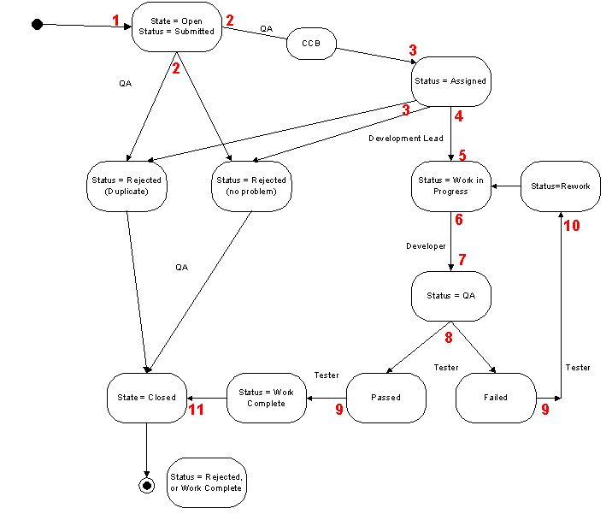
(1) SCR is created
(2) QA Reviews, sets Severity, & eliminates duplicates.
(3) QA sets status to assigned & assigns SCR to team lead.
(4) Team lead sets Priorities.
(5) Team lead assigns SCRs to team members.
(6) Team repairs product & updates the SCRs with a resolution note.
(7) Team sets status to QA.
(8) QA verifies the SCR resolution.
(9) QA sets status to Work Completed or Rework.
(10) SCRs with a status of rework are reassigned to the team lead.
(11) QA Closes Completed SCRs

  - Maintenance Change Request Workflow
(1) SCR is created
(2) QA Reviews, sets Severity, & eliminates duplicates.
(3) CCB reviews, prioritizes, & assigns SCRs.
(4) Team Develops maintenance plan.
(5) Team lead assigns SCRs to team members.
(6) Team repairs product & updates the SCRs with a resolution note.
(7) Team sets status to QA.
(8) QA verifies the SCR resolution.
(9) QA sets status to Ready for Release or Rework.
(10) SCRs with a status of rework are reassigned to the team lead.
(11) QA Closes Completed SCRs when updated product is moved to production.

  - SmartSim Submit SCR Form

Below is the SmartSim Submit page. This form is used to report any issues found within a Simulation. All fields asterisked with a RED diamond must be completed in order to submit the SCR. Fields preceded with GREEN diamonds are not required. They are, however, automatically populated with default values that can be changed if necessary.

SCR ID: Description - A generated number identifying the SCR. Each SCR will have a unique ID number.
Instructions - Tracker will automatically populate this field after the SCR is submitted. The user is unable to enter anything into this field.

SCR Title: Description - Title of the SCR.
Instructions - This is a required field. Create a one-sentence explanation of the issue. Keep the title within the given area (Ex. Glossary link "k" takes Learner to "D"). The clearer the explanation, the easier it is for everyone who needs to find and fix the issue. **Note: Do not say "Missing graphic." Be more specific (i.e. Missing graphic in Meet with manager conversation).

Severity: Description - Indicates the amount of impact the issue has on the product's functionality or usability.
Instructions - Select the severity from the drop-down list. The severity levels are as follows:

6 - Unknown - Any issue where the impact to the product’s usability or functionality is unknown at the time of entry. These issues will be analyzed and their impact assessed at which time a severity will be assigned.
5 - Enhancement - Any new feature or content that does not currently exist in the product and is not needed to resolve any product defect. Some examples are adding new conversations or updating the content to reflect new information, adding new features or functions, etc.
4 - Low - Functional issues that are considered cosmetic in nature and have no impact on the usability or effectiveness of the product. Some examples are incorrect colors, character voices that do not match the graphical representation (with the exception of male/female mismatch), character accents that are difficult to understand, misplaced buttons, inconsistent appearance that does not impact usability, etc.
3 - Medium - Functional issues that are obvious to the user, but do not significantly impact usability of the product. Some examples are the appearance of incorrect graphics on the desktop, misaligned or non-proportional graphics, double-firing reflections, “none at this time” missing from reflections with no information, incomplete transcript information, functionality that meets technical requirements but is difficult to use or find, etc.
2 - High - Functional issues that significantly impact the user’s ability to use the product. Some examples are misspelled words, poor grammar, misleading or incorrect information, instructions or actions that are not clearly explained, missing non-essential graphics and missing or mismatched audio, functions or features that do not function as specified in the product requirements, missing error messages, etc.
1 - Critical - Functional or technical issues that prevent the user from using the product. Some examples are software or system failures, logic loops, missing essential graphics, missing props, offensive or stereotypical content, information or functionality that is not in line with customer requirements, or significant functionality or features that are missing or not functioning, etc.

Submitter: Description - The name of the individual who submitted the SCR.
Instructions - This field automatically populates according to the login name; all people with access are listed.

Submit Date: Description - The date the SCR was entered into the system.
Instructions - This field automatically populates to the time you opened the submit SCR form; it is possible to select the clock which will populate the field with the current time and date. This field can be edited or manually entered. Include month/day/year and time (Ex. 1/1/02 12:31:04 PM).

Sim Title: Description - Name of the Simulation in which the issue was found
Instructions - Input the name of the simulation (Ex. Influencing decision makers).

Sim Devcode: Description - Title ID of the Simulation in which the issue was found - the development code.
Instructions - Select the sim code from the drop-down list. All Devcodes are in alphabetical order. Note: The Migration Tool and Runtime have been added to this section; however, only the QA team should select these options.

Date found: Description - Date when the issue was found, if applicable.
Instructions - This field automatically populates to the time you opened the submit SCR form; it is possible to select the clock which will populate the field with the current time and date. This field can be edited or manually entered. Include month/day/year and time . (Ex. 1/1/02 12:31:04 PM).

Date last working: Description - Date when sim last worked correctly, if applicable.
Instructions - This field automatically populates to when you opened the submit SCR form; selecting the clock will populate the field with the current time and date. This field can be edited or manually entered. Include month/day/year and time (Ex. 1/1/02 12:31:04 PM).

Problem Area: Description - General area of Sim where the problem was found.
Instructions - Select the problem area from the drop-down list. The following is a list of problem areas and common issues that arise within each:

Briefcase Doc - white papers, articles, research, etc.
- Controls - alt-text, functionality
- Media - missing or distorted graphics
- Content - intended realism; appropriateness
- Text - edits - grammar, spelling, spacing, capitalization, punctuation, etc.
Conversation - all issues within a conversation
- Media missing or substandard graphics and audio
- Content - Americanisms, stereotypes, offensive language, wrong, outdated or questionable content, negative endorsements
- Text - text does not match audio; edits - grammar, spelling, spacing, notes to actors, capitalization, punctuation, etc.
- Flow - statements not hidden, transitions, loops, and other rule-specific issues
- Performance bar (character's mood) - movement, spelling
e-mail - all parts of an email
- Content - character name, format
- Text - edits - grammar, spelling, spacing, capitalization, punctuation, etc.
- Flow - Guest/LearnerName issues
entire simulation - elements that are seen completely throughout the simulation
- Used only when entire audio or graphics are missing from the simulation or when the sim has reoccurring problems, such as misspelled or inaccurately capitalized title
Intro - the beginning of the simulation element
- Controls - button functionality
- Audio - quality of sound; timing
- Graphics - timing; distortion; appropriateness
- Content - intended realism; instructions
- Text - edits - grammar, spelling, spacing, capitalization, punctuation, etc.
- Flow - automatic start from introduction to desktop, smooth transitions
Learner Map - an interactive screen that provides conversational information (characters, objectives, next steps) and paths through the simulation
- Controls - alt-text, functionality
- Content - intended realism; appropriateness, instructions
- Text - edits - grammar, spelling, spacing, capitalization, punctuation, etc.
Performance Bar - feedback based on character attitude and overall performance regarding the objectives of the simulation
- Text - edits - grammar, spelling, spacing, naming
- Flow - movement throughout simulation
Reflection - feedback provided at the end of a conversation or simulation
- Controls - alt-text, functionality
- Content - intended realism; appropriateness, direction
- Text - edits - grammar, spelling, spacing, capitalization, punctuation, etc.
- Flow - double firing, missing, contradicting
Runtime - the simulation that is seen within a browser; include those items that work in xNet Workbench but not online
- Controls - alt-text, functionality
- Media - missing or distorted graphics; war stories quality and appropriateness
- Flow - double firing, missing, contradicting
Sage - the knowledge repository of information for the simulation; includes War Stories
- Controls - alt-text, functionality
- Media - missing or distorted graphics; war stories quality and appropriateness
- Content - appropriateness, war story description, glossary, help
- Text - edits - grammar, spelling, spacing, capitalization, punctuation, etc.
Sim Help - includes the Interactive tutorial, help index, FAQ, and Accessibility information
- Controls - Introduction button and hyperlink functionality
- Audio - quality of sound; timing
- Graphics - timing; distortion; appropriateness
- Content - intended realism; instructions
- Text - edits - grammar, spelling, spacing, capitalization, punctuation, etc.
Transcript - a statement and response account of the path took within a conversation or simulation
- Controls - button functionality
- Content - missing statement/response
- Text - edits - grammar, spelling, spacing, capitalization, punctuation, etc.
- Flow - LearnerName
User Interface - simulation templates, buttons, how the user performs actions
- Controls - alt-text, functionality, yes/no/cancel option, button naming
- Graphics - distortion; appropriateness
Web Site - the fictional Internet/intranet site for the simulation
- Controls - alt-text, functionality
- Media - missing or distorted graphics; any audio, if present
- Content - intended realism; appropriateness
- Text - edits - grammar, spelling, spacing, capitalization, punctuation, etc.

Conversation: Description - The Sim conversation in which the issue is located
Instructions - Write out the entire name of the conversation where the issue is located, if necessary (Ex. Meeting with boss). **Note: Do not say “Conversation 2.

Found in Location: Description - The environment or server where the issue was found.
Instructions - Select the environment from the drop-down list. Available locations include:

Scottsdale Development - the simulation server in Scottsdale used by the Scottsdale development team.
Scottsdale QA - the simulation testing server in Scottsdale used by reviewers
Dev02 - a server in Dublin used for testing learning objects
System Test - a server in Redwood City used for testing learning objects
Staging - a server in Redwood City used for previewing learning objects
Production - place where paying customers gain access to learning objects
CD-ROM - simulations that have been put on CDs for local use

Operating System: Description - The system which the computer has installed to run and coordinate all other applications.
Instructions - Select the operating system from the drop-down list. Available systems include:

Windows 95
Windows 98
Windows 2K
Windows NT
Windows XP
Mac OS9
Mac OS10
Linux
Unix

Browser Used: Description - The Internet application the computer uses.
Instructions - Select the browser used from the drop-down list. Selections are as follows:

IE6.2
IE6.0
IE5.5
IE5.0
IE4.6
IE4.7
Netscape 6.2
Netscape 6.0
Netscape 4.7

Found in Runtime Version #: Description - Runtime/Workbench Version number where the issue was found
Instructions - Select the version number in which the issue was found from the drop-down list. Version numbers include:

1.0
2.5
2.5b
2.5c
2.6
2.6a

Found in Development Phase: Description - The Development Lifecycle phase during which the issue was found - based on Project Plans.
Instructions - Select the development activity during which the issue was found from the drop-down list. Development activities include:

Unit Testing - the simulation is being tested by the developers on a conversation-by-conversation basis
Copyedit - the content is being copyedited
MediaReview - a review of the media content for a particular learning object
Conversation Flow Review - the simulation's content and flow are being reviewed
Pilot Review - review of all the elements of a simulation
Integration Testing - the final testing review before it leaves Scottsdale QA server
System Testing - testing performed on the testing server; looks at the entire learning path
Implementation Testing - testing done each time a learning object is placed on a different server
Production - the sim is available to paying customers
Not Applicable - the development activity is not applicable in this situation

Project Id: Description - The project to which the SCR has been assigned - using the SDC project naming standards.
Instructions - Input the specific simulation Project Id using the SDC project naming standards - this should be the same ID that is used in Project Central.

Description: Description - A detailed description of the issue.
Instructions - Input a specific step-by-step process of what the problem is and how to recreate it. The more detail in the description the better. Remember, conciseness is a good thing.

A good example:
Missing graphic in Sage Document
Select Sage from desktop
Expand the “Localize the problem” document
Use the scroll function to display the graphics at the bottom of the document
The last graphic in the document is missing

Please try not to use sentences like:
“I went into Sage and found a missing graphic when I was looking at one of the documents.” OR
“You need to go to Sage. Then you should open your Localize document. Then you need to scroll to the bottom of your screen and look at the graphics.”

At the bottom of the form, click OK when the SCR is ready to be submitted.

  - SmartSim Update SCR Form

Below is the Update SmartSim form. This form is used to update Simulations issues that have already been documented. All fields asterisked with a RED diamond must be completed in order to submit the SCR. Fields preceded with GREEN diamonds are not required. They are, however, automatically populated with default values that can be changed if necessary.

The following fields are those that are different from the SmartSim Submit SCR form.

Note: See the SmartSim Submit form for a list of the fields that are not seen below.

SCR Status: Description - Indicates where in the SCR lifecycle process the SCR is.
Instructions - Select the SCR status from the drop-down list. Available status indications and their meanings are as follows:

Submitted - the SCR has been entered into the project database
CCB - Change Control Board is addressing issue
Rejected (dup) - the SCR was a duplicate to another issue
Rejected (no problem) - the issue was not able to be reproduced or is not a valid problem
Pending - it is an SCR that has been assigned but for some reason cannot be worked on immediately.
Postponed - work on the SCR has been stopped indefinitely
Research - the SCR needs to be researched to determine a course of action
Assigned - the SCR has been delegated to a specific person
Rework - problems still exist to the issue and need to be re-addressed
Work in Progress - the SCR is being addressed at this time
QA - the QA team is verifying if the issue has been fixed or needs to be reworked
Awaiting release - the SCR has been fixed and is ready to be released
Work Complete - the SCR has been released and the issue is closed

Priority: Description - Priority of the SCR in relation to other SCRs. This provides guidance on the order in which SCRs should be addressed; set by the CCB (Change Control Board).
Instructions - Select the level of priority from the drop-down list. The priority levels are as follows:

1 - Required - has to be fixed before the simulation will be allowed to go to System Test
2 - Preferred - preferred that the issues is fixed before move to System Test
3 - Do if time permits - the last priority to be addressed/fixed

SCR Resolution: Description - Resolution of the SCR, not what was done to resolve the issue.
Instructions - Select the SCR resolution from the drop-down list. Resolutions are as follows:

Fixed - indicates the issue has been fixed
Duplicate - indicates the issue is the same as another SCR
Postpone - indicates that a decision was made to fix the problem at a later date (that date may or may not have been set)
Not Repeatable - indicates the issue cannot be repeated
Do not fix - indicates that either the issue has been acknowledged as a problem but a decision to never fix the problem has been made or that the issue was not a problem at all

TBD - indicates the resolution has not yet been determined

Duplicate CR#: Description - ID number of the SCR that this SCR duplicates
Instructions - Run a query on the Devcode and get a list of all issues entered for that sim. Search the list of open SCRs for duplicates. If a duplicate exists, enter the SCR ID number in this field. Be sure to set SCR Status to Rejected (Duplicate). This should only be done on one SCR or the other, not on both.

State: Description - Indicates if the SCR is open or closed.
Instructions - This field is not editable by some users due to permissions. Only the QA team has access.

Audio Recording Needed: Description - An Audio recoding is needed to resolve this issue.
Instructions - Select whether or not audio recording is necessary from the drop-down list.

yes - if recording is needed
no - if recording is not needed

Assignee: Description - Owner - the person assigned to fix, investigate or verify the SCR.
Instructions - Only change this field if the issue cannot be completed by the assignee (EX. a tech team or media issue). If necessary, select the contact person from the drop down list.

Estimated repair hours: Description - Estimated number of hours needed to resolve the issue
Instructions - Input the number of hours a solution and fix is estimated to take. Enter only numbers in this field (Ex. 10). Note: This field may not be editable to some users due to permissions.

Verified Fix: Description - The date the fix was verified by QA.
Instructions - Do not enter anything in this field unless you are a member of the QA team. If a member of the QA team, enter the date that the fix was verified or select the clock in order to automatically populate the field with the current time and date. This field can be edited or manually entered. Include month/day/year and time (Ex. 1/1/02 12:31:04 PM).

Actual release date: Description - The date the resolution or change was implemented.
Instructions - Fill in the field with a date or select the clock, which will populate the field with the current time and date. This field can be edited or manually entered. Include month/day/year and time (Ex. 1/1/02 12:31:04 PM).

Close Date: Description - The date the SCR was closed.
Instructions - This field automatically populates to the time you opened the Update SmartSim SCR form; selecting the clock will populate the field with the current time and date. This field can be edited or manually entered. Include month/day/year and time (Ex. 1/1/02 12:31:04 PM).

At the bottom of the form, click OK when SCR is ready to be updated.
  - SimTool Submit SCR Form

Below is the Sim Tool Submit page. This form is used to report any xNet Workbench issues. All fields asterisked with a RED diamond must be completed in order to submit the SCR. Fields preceded with GREEN diamonds are not required. They are, however, automatically populated with default values that can be changed if necessary.

SCR ID: Description - A generated number identifying the SCR. Each SCR will have a unique ID number.
Instructions - Tracker will automatically populate this field after the SCR is submitted. The user is unable to enter anything into this field.

SCR Title: Description - Title of the SCR.
Instructions - This is a required field. Create a one-sentence explanation of the issue. Keep the title within the given area (Ex. Glossary link "k" takes Learner to "D"). The clearer the explanation, the easier it is for everyone who needs to find and fix the issue. **Note: Do not say "Missing graphic." Be more specific (i.e. Missing graphic in Meet with manager conversation).

Severity: Description - Indicates the amount of impact the issue has on the product's functionality or usability.
Instructions - Select the severity from the drop-down list. The severity levels are as follows:

6 - Unknown - Any issue where the impact to the product’s usability or functionality is unknown at the time of entry. These issues will be analyzed and their impact assessed at which time a severity will be assigned.
5 - Enhancement - Any new feature or content that does not currently exist in the product and is not needed to resolve any product defect. Some examples are adding new conversations or updating the content to reflect new information, adding new features or functions, etc.
4 - Low - Functional issues that are considered cosmetic in nature and have no impact on the usability or effectiveness of the product. Some examples are incorrect colors, character voices that do not match the graphical representation (with the exception of male/female mismatch), character accents that are difficult to understand, misplaced buttons, inconsistent appearance that does not impact usability, etc.
3 - Medium - Functional issues that are obvious to the user, but do not significantly impact usability of the product. Some examples are the appearance of incorrect graphics on the desktop, misaligned or non-proportional graphics, double-firing reflections, “none at this time” missing from reflections with no information, incomplete transcript information, functionality that meets technical requirements but is difficult to use or find, etc.
2 - High - Functional issues that significantly impact the user’s ability to use the product. Some examples are misspelled words, poor grammar, misleading or incorrect information, instructions or actions that are not clearly explained, missing non-essential graphics and missing or mismatched audio, functions or features that do not function as specified in the product requirements, missing error messages, etc.
1 - Critical - Functional or technical issues that prevent the user from using the product. Some examples are software or system failures, logic loops, missing essential graphics, missing props, offensive or stereotypical content, information or functionality that is not in line with customer requirements, or significant functionality or features that are missing or not functioning, etc.

Sim Devcode: Description - Title ID of the Simulation in which the issue was found - the development code.
Instructions - Select the sim code from the drop-down list. Also included is “Not Applicable” for issues not directly connected to any one sim.

Submitter: Description - The name of the individual who submitted the SCR.
Instructions - This field automatically populates according to the login name; all people with access are listed.

Submit Date: Description - The date the SCR was entered into the system.
Instructions - This field automatically populates to the time you opened the submit SCR form; it is possible to select the clock which will populate the field with the current time and date. This field can be edited or manually entered. Include month/day/year and time (Ex. 1/1/02 12:31:04 PM).

Date found: Description - Date when the issue was found, if applicable.
Instructions - This field automatically populates to the time you opened the submit SCR form; it is possible to select the clock which will populate the field with the current time and date. This field can be edited or manually entered. Include month/day/year and time. (Ex. 1/1/02 12:31:04 PM).

Date last working: Description - Date when sim last worked correctly, if applicable.
Instructions - This field automatically populates to when you opened the submit SCR form; selecting the clock will populate the field with the current time and date. This field can be edited or manually entered. Include month/day/year and time (Ex. 1/1/02 12:31:04 PM).

Operating System: Description - The system which the computer has installed to run and coordinate all other applications.
Instructions - Select the operating system from the drop-down list. Available systems include:

Windows 95
Windows 98
Windows 2K
Windows NT
Macintosh

Found in Development Phase: Description - The Development Lifecycle phase during which the issue was found - based on Project Plans.
Instructions - Select the development phase in which the problem was found from the drop-down list. The phases are as follows:

Requirements- when requirements for a new version are being gathered
Design - the software analysis and design based on the requirements
Code - the actual programming based on the design and requirements
Unit Testing - module testing
System Testing - testing of the whole version; all parts put together
Production - when the version is rolled out to the users

Workbench Area: Description - The place in the Workbench the issue was found.
Instructions - Select the Workbench area in which the problem was found from the drop-down list. The Workbench areas are as follows:

Actions - any issue that relates to a specific action
Conditionals - any issue that relates to a specific conditional
Deployment - any issue that relates to deployment
Events - any issue that relates to a specific event
Miscellaneous - any other issue that cannot be categorized
Objectives - an issue that relates to objectives found in the World
People - any issue that relates to the People section in the World
Places - any issue that relates to the Places section in the World
Reflections - any issue that relates to Reflections
Reports - any issue that relates to Reports - access database reports
Tasks - any issue that relates to specific tasks
Triggers - an issue that relates to triggers found in the World
World Props - any issue that relates to the Props section in the World
Unknown - do not know the area

Found in Workbench Version #: Description - Workbench Version number where the issue was found
Instructions - Select the version number in which the problem was found from the drop-down list. Current versions include:

1.0
2.5
2.5b
2.5c
2.6
2.6a
<<unknown>>

Description: Description - A detailed description of the issue.
Instructions - Input a specific step-by-step process of what the problem is and how to recreate it. The more detail in the description the better. Most importantly, in the description, please mention the specific event, action, etc. where the issue was found (Ex. event - onConversationEnter, onTitleBegin; action - SetPropActive, GetItemValue). It is also good to add anything you think is relevant.

A good example:
Found in OnConversationEnd event, inside conditional with GetItemValue action
From conversation window, right click on the OnCconversationEnd event.
Chose Add Conditional, Selected GetItemValue.
When GetItemValue window appeared, selected World,
Chose the "test objective" objective
Created variant "50", and selected greater than or equal
In the Then section, added reflection, Good point; In the Else section, added reflection, Areas for improvement.
When in the Title Test bed, the rule does not function properly. It seems to only work if the value is less than 50 and the AFI appears.

At the bottom of the form, click OK when SCR is ready to be submitted.

  - SimTool Update SCR Form

Below is the Sim Tool Update page. This form is used to update Sim Tool issues that have already been documented. All fields asterisked with a RED diamond must be completed in order to submit the SCR. Fields preceded with GREEN diamonds are not required. They are, however, automatically populated with default values that can be changed if necessary.

The following fields are those that are different from the Sim Tool Submit SCR form.

Note: See the Sim Tool Submit form for a list of the fields that are not seen below.

SCR Status: Description - Indicates where in the SCR lifecycle process the SCR is.
Instructions - Select the SCR status from the drop-down list. Available status indications and their meanings are as follows:

Submitted - the SCR has been entered into the project database
CCB - Change Control Board is addressing issue
Rejected (dup) - the SCR was a duplicate to another issue
Rejected (no problem) - the issue was not able to be reproduced or is not a valid problem
Pending - it is an SCR that has been assigned but for some reason cannot be worked on immediately.
Postponed - work on the SCR has been stopped indefinitely
Research - the SCR needs to be researched to determine a course of action
Assigned - the SCR has been delegated to a specific person
Rework - problems still exist to the issue and need to be re-addressed
Work in Progress - the SCR is being addressed at this time
QA - the QA team is verifying if the issue has been fixed or needs to be reworked
Awaiting release - the SCR has been fixed and is ready to be released
Work Complete - the SCR has been released and the issue is closed

Priority: Description - Priority of the SCR in relation to other SCRs. This provides guidance on the order in which SCRs should be addressed; set by the CCB (Change Control Board).
Instructions - Select the level of priority from the drop-down list. The priority levels are as follows:

1 - Required - has to be fixed before the simulation will be allowed to go to System Test
2 - Preferred - preferred that the issues is fixed before move to System Test
3 - Do if time permits - the last priority to be addressed/fixed

SCR Resolution: Description - Resolution of the SCR, not what was done to resolve the issue.
Instructions - Select the SCR resolution from the drop-down list. Resolutions are as follows:

Fixed - indicates the issue has been fixed
Duplicate - indicates the issue is the same as another SCR
Postpone - indicates that a decision was made to fix the problem at a later date (that date may or may not have been set)
Not Repeatable - indicates the issue cannot be repeated
Do not fix - indicates that either the issue has been acknowledged as a problem, but a decision to never fix the problem has been made or that the issue was not a problem at all

Duplicate CR#: Description - ID number of the SCR that this SCR duplicates
Instructions - Run a query on the Devcode and get a list of all issues entered for that sim. Search the list of open SCRs for duplicates. If a duplicate exists, enter the SCR ID number in this field. Be sure to set SCR Status to Rejected (Duplicate). This should only be done on one SCR or the other, not on both.

State: Description - Indicates if the SCR is open or closed.
Instructions - This field is not editable by some users due to permissions. Only the QA team has access.

Assignee: Description - Owner - the person assigned to fix, investigate or verify the SCR.
Instructions - Only change this field if the issue cannot be completed by the assignee (EX. a tech team or media issue). If necessary, select the contact person from the drop down list.

Estimated repair hours: Description - Estimated number of hours needed to resolve the issue
Instructions - Input the number of hours a solution and fix is estimated to take. Enter only numbers in this field (Ex. 10). Note: This field may not be editable to some users due to permissions.

Target Workbench Version: Description - Target release for xNet Workbench.
Instructions - Select the target Workbench Version from the drop-down list. Choices are as follows:

2.6b
2.7
2.8
TBD

Actual release date: Description - The date the resolution or change was implemented.
Instructions - Enter the date in this field or select the clock, which will populate the field with the current time. This field can be edited or manually entered. Include month/day/year and time (Ex. 1/1/02 12:31:04 PM).

Close Date: Description - The date the SCR was closed.
Instructions - This field automatically populates to the time you opened the submit SCR form; selecting the clock will populate the field with the current time. This field can be edited or manually entered. Include month/day/year and time (Ex. 1/1/02 12:31:04 PM).

At the bottom of the form, click OK when SCR is ready to be updated.

  - Sage Tool Submit SCR Form

Below is the Sage Tool Submit page. This is the form used to report any Sage Tool issues. All fields asterisked with a RED Diamond must be completed in order to submit the SCR. Fields preceded with GREEN diamonds are not required. They are, however, automatically populated with default values that can be changed if necessary.

SCR ID: Description - A generated number identifying the SCR. Each SCR will have a unique ID number.
Instructions - Tracker will automatically populate this field after the SCR is submitted. The user is unable to enter anything into this field.

SCR Title: Description - Title of the SCR.
Instructions - This is a required field. Create a one-sentence explanation of the issue. Keep the title within the given area (Ex. Glossary link "k" takes Learner to "D"). The clearer the explanation, the easier it is for everyone who needs to find and fix the issue. **Note: Do not say "Missing graphic." Be more specific (i.e. Missing graphic in Meet with manager conversation).

Submitter: Description - The name of the individual who submitted the SCR.
Instructions - This field automatically populates according to the login name; all people with access are listed.

Submit Date: Description - The date the SCR was entered into the system.
Instructions - This field automatically populates to the time you opened the submit SCR form; it is possible to select the clock which will populate the field with the current time and date. This field can be edited or manually entered. Include month/day/year and time (Ex. 1/1/02 12:31:04 PM).

Date found: Description - Date when the issue was found, (if applicable).
Instructions - This field automatically populates to the time you opened the submit SCR form; it is possible to select the clock which will populate the field with the current time and date. This field can be edited or manually entered. Include month/day/year and time (Ex. 1/1/02 12:31:04 PM).

Found in Sage Version: Description - Version of Sage when problem was found.
Instructions - Select the version of the Sage Tool in which the issue was found from the drop-down list. The version number will appear in the DOS window whenever the Sage application is started. Current versions include:

1.0.0
1.1.0
1.2.0
2.0.0

Found in Platform Version: Description - Version of SmartForce Desktop Environment where problem was found.
Instructions - Select the platform version of the Sage Tool in which the issue was found from the drop-down list. The version number will appear on the title bar. Current versions include:

1.1.0
1.2.0

Found in Development Phase: Description - The Development Lifecycle phase during which the issue was found.
Instructions - Select the development phase in which the problem was found from the drop-down list. For many users, this field is not visible due to permissions. The phases are as follows:

Requirements- when requirements for a new version are being gathered
Design - the software analysis and design based on the requirements
Code - the actual programming based on the design and requirements
Unit Testing - module testing
System Testing - testing of the whole version; all parts put together
Production - when the version is rolled out to the users

Description: Description - A detailed description of the issue.
Instructions - Input a specific step-by-step process of what the problem is and how to recreate it. The more detail in the description the better. Most importantly, in the description, specify exactly where the issue was found. It is also good to add anything you think is relevant.

A good example:
The bold key does not bold, it italicizes
Select Bold Key at top of Sage Tool
After pressing, the text becomes italicized.

At the bottom of the form, click OK when SCR is ready to be submitted.

  - Sage Tool Update SCR Form

Below is the Sage Tool Update page. This form is used to update Sage Tool issues that have already been documented. All fields asterisked with a RED diamond must be completed in order to submit the SCR. Fields preceded with GREEN diamonds are not required. They are, however, automatically populated with default values that can be changed if necessary.

The following fields are those that are different from the Sage Tool Submit SCR form.

Note: See the Sage Tool Submit form for a list of the fields that are not seen below.

SCR Status: Description - Indicates where in the SCR lifecycle process the SCR is.
Instructions - Select the SCR status from the drop-down list. Available status indications and their meanings are as follows:

Submitted - the SCR has been entered into the project database
CCB - Change Control Board is addressing issue
Rejected (dup) - the SCR was a duplicate to another issue
Rejected (no problem) - the issue was not able to be reproduced or is not a valid problem
Pending - it is an SCR that has been assigned but for some reason cannot be worked on immediately.
Postponed - work on the SCR has been stopped indefinitely
Research - the SCR needs to be researched to determine a course of action
Assigned - the SCR has been delegated to a specific person
Rework - problems still exist to the issue and need to be re-addressed
Work in Progress - the SCR is being addressed at this time
QA - the QA team is verifying if the issue has been fixed or needs to be reworked
Awaiting release - the SCR has been fixed and is ready to be released
Work Complete - the SCR has been released and the issue is closed

SCR Resolution: Description - Resolution of the SCR, not what was done to resolve the issue.
Instructions - Select the resolution level from the drop-down list. Resolutions are as follows:

Fixed - indicates the issue has been fixed
Postpone - indicates that a decision was made to fix the problem at a later date (that date may or may not have been set)
Duplicate - indicates the issue is the same as another SCR
Do not fix - indicates that either the issue has been acknowledged as a problem but that a decision to never fix the problem has been made or that the issue was not a problem at all
Not Repeatable - indicates the issue cannot be repeated

Duplicate CR#: Description - ID number of the SCR that this SCR duplicates
Instructions - Run a query on the Devcode and get a list of all issues entered for that sim. Search the list of open SCRs for duplicates. If a duplicate exists, enter the SCR ID number in this field. Be sure to set SCR Status to Rejected (Duplicate). This should only be done on one SCR or the other, not on both.

Severity: Description - Indicates the amount of impact the issue has on the product's functionality or usability.
Instructions - Select the severity from the drop-down list. The severity levels are as follows:

6 - Unknown - Any issue where the impact to the product’s usability or functionality is unknown at the time of entry. These issues will be analyzed and their impact assessed at which time a severity will be assigned.
5 - Enhancement - Any new feature or content that does not currently exist in the product and is not needed to resolve any product defect. Some examples are adding new conversations or updating the content to reflect new information, adding new features or functions, etc.
4 - Low - Functional issues that are considered cosmetic in nature and have no impact on the usability or effectiveness of the product. Some examples are incorrect colors, character voices that do not match the graphical representation (with the exception of male/female mismatch), character accents that are difficult to understand, misplaced buttons, inconsistent appearance that does not impact usability, etc.
3 - Medium - Functional issues that are obvious to the user, but do not significantly impact usability of the product. Some examples are the appearance of incorrect graphics on the desktop, misaligned or non-proportional graphics, double-firing reflections, “none at this time” missing from reflections with no information, incomplete transcript information, functionality that meets technical requirements but is difficult to use or find, etc.
2 - High - Functional issues that significantly impact the user’s ability to use the product. Some examples are misspelled words, poor grammar, misleading or incorrect information, instructions or actions that are not clearly explained, missing non-essential graphics and missing or mismatched audio, functions or features that do not function as specified in the product requirements, missing error messages, etc.
1 - Critical - Functional or technical issues that prevent the user from using the product. Some examples are software or system failures, logic loops, missing essential graphics, missing props, offensive or stereotypical content, information or functionality that is not in line with customer requirements, or significant functionality or features that are missing or not functioning, etc.

Priority: Description - Priority of the SCR in relation to other SCRs. This provides guidance on the order in which SCRs should be addressed; set by the CCB (Change Control Board).
Instructions - Select the level of priority from the drop-down list. The priority levels are as follows:

1 - Required - has to be fixed before the simulation will be allowed to go to System Test
2 - Preferred - preferred that the issues is fixed before move to System Test
3 - Do if time permits - the last priority to be addressed/fixed

Assignee: Description - Owner - the person assigned to fix, investigate or verify the SCR.
Instructions - This is a required field. Only change this field if the issue cannot be completed by the assignee (EX. a tech team or media issue). If necessary, select the contact person from the drop down list.

Estimated repair hours: Description - Estimated number of hours needed to resolve the issue
Instructions - Input the number of hours a solution and fix is estimated to take. Enter only numbers in this field (Ex. 10). Note: This field may not be editable to some users due to permissions.

Target Sage Version: Description - Target release for Sage.
Instructions - Select the Sage version from the drop-down list. Choices include:

1.0.0
1.1.0
1.2.0
2.0.0
TBD - to be determined

Actual release date: Description – The date the resolution or change was implemented.
Instructions - Enter the date in this field or select the clock, which will populate the field with the current time. This field can be edited or manually entered. Include month/day/year and time (Ex. 1/1/02 12:31:04 PM).

Close Date: Description - The date the SCR was closed.
Instructions - This field automatically populates to the time you opened the submit SCR form; selecting the clock will populate the field with the current time. This field can be edited or manually entered. Include month/day/year and time (Ex. 1/1/02 12:31:04 PM).

At the bottom of the form, click OK when SCR is ready to be updated.

  - PVCS Tracker Submit SCR Form

Below is the PVCS Tracker Submit page. This form is used to record issues found with Tracker itself. All fields asterisked with a RED Diamond must be completed in order to submit the SCR. The fields preceded with GREEN diamonds are not required . They are, however, automatically populated with default values that can be changed if necessary.

SCR ID: Description - A generated number identifying the SCR. Each SCR will have a unique ID number.
Instructions - Tracker will automatically populate this field after the SCR is submitted. The user is unable to enter anything into this field.

SCR Title: Description - Title of the SCR.
Instructions - This is a required field. Create a one-sentence explanation of the issue. Keep the title within the given area (Ex. Glossary link "k" takes Learner to "D"). The clearer the explanation, the easier it is for everyone who needs to find and fix the issue. **Note: Do not say "Missing graphic." Be more specific (i.e. Missing graphic in Meet with manager conversation).
.

Submitter: Description - The name of the individual who submitted the SCR.
Instructions - This field automatically populates according to the login name; all people with access are listed.

Submit Date: Description - The date the SCR was entered into the system.
Instructions - This field automatically populates to the time you opened the submit SCR form; it is possible to select the clock which will populate the field with the current time and date. This field can be edited or manually entered. Include month/day/year and time (Ex. 1/1/02 12:31:04 PM).

Severity: Description - Indicates the amount of impact the issue has on the product's functionality or usability.
Instructions - Select the severity from the drop-down list. The severity levels are as follows:

6 - Unknown - Any issue where the impact to the product’s usability or functionality is unknown at the time of entry. These issues will be analyzed and their impact assessed at which time a severity will be assigned.
5 - Enhancement - Any new feature or content that does not currently exist in the product and is not needed to resolve any product defect. Some examples are adding new conversations or updating the content to reflect new information, adding new features or functions, etc.
4 - Low - Functional issues that are considered cosmetic in nature and have no impact on the usability or effectiveness of the product. Some examples are incorrect colors, character voices that do not match the graphical representation (with the exception of male/female mismatch), character accents that are difficult to understand, misplaced buttons, inconsistent appearance that does not impact usability, etc.
3 - Medium - Functional issues that are obvious to the user, but do not significantly impact usability of the product. Some examples are the appearance of incorrect graphics on the desktop, misaligned or non-proportional graphics, double-firing reflections, “none at this time” missing from reflections with no information, incomplete transcript information, functionality that meets technical requirements but is difficult to use or find, etc.
2 - High - Functional issues that significantly impact the user’s ability to use the product. Some examples are misspelled words, poor grammar, misleading or incorrect information, instructions or actions that are not clearly explained, missing non-essential graphics and missing or mismatched audio, functions or features that do not function as specified in the product requirements, missing error messages, etc.
1 - Critical - Functional or technical issues that prevent the user from using the product. Some examples are software or system failures, logic loops, missing essential graphics, missing props, offensive or stereotypical content, information or functionality that is not in line with customer requirements, or significant functionality or features that are missing or not functioning, etc.

Date found: Description - Date when the issue was found, if applicable.
Instructions - This field automatically populates to the time you opened the submit SCR form; it is possible to select the clock which will populate the field with the current time and date. This field can be edited or manually entered. Include month/day/year and time (Ex. 1/1/02 12:31:04 PM).

Description: Description - A detailed description of the issue.
Instructions - Input a specific step-by-step process of what the problem is and how to recreate it. The more detail in the description the better. Most importantly, in the description, specify exactly where the issue was found. It is also good to add anything you think is relevant.

A good example:
The Date Found field is misspelled … it reads Date Fund.

At the bottom of the form, click OK when SCR is ready to be submitted.

  - Thick Client Platform Submit SCR Instructions

Below is the Thick Client Platform Submit page. This form is used to report any issues found within any of the SmartForce Desktop Environments. All fields asterisked with a RED Diamond must be completed in order to submit the SCR. Fields preceded with GREEN diamonds are not required. They are, however, automatically populated with default values that can be changed if necessary.

SCR ID: Description - A generated number identifying the SCR. Each SCR will have a unique ID number.
Instructions - Tracker will automatically populate this field after the SCR is submitted. The user is unable to enter anything into this field.

SCR Title: Description - Title of the SCR.
Instructions - This is a required field. Create a one-sentence explanation of the issue. Keep the title within the given area (Ex. Glossary link "k" takes Learner to "D"). The clearer the explanation, the easier it is for everyone who needs to find and fix the issue. **Note: Do not say "Missing graphic." Be more specific (i.e. Missing graphic in Meet with manager conversation).
.

Submitter: Description - The name of the individual who submitted the SCR.
Instructions - This field automatically populates according to the login name; all people with access are listed.

Submit Date: Description - The date the SCR was entered into the system.
Instructions - This field automatically populates to the time you opened the submit SCR form; it is possible to select the clock which will populate the field with the current time and date. This field can be edited or manually entered. Include month/day/year and time (Ex. 1/1/02 12:31:04 PM).

Severity: Description - Indicates the amount of impact the issue has on the product's functionality or usability.
Instructions - Select the severity from the drop-down list. The severity levels are as follows:

6 - Unknown - Any issue where the impact to the product’s usability or functionality is unknown at the time of entry. These issues will be analyzed and their impact assessed at which time a severity will be assigned.
5 - Enhancement - Any new feature or content that does not currently exist in the product and is not needed to resolve any product defect. Some examples are adding new conversations or updating the content to reflect new information, adding new features or functions, etc.
4 - Low - Functional issues that are considered cosmetic in nature and have no impact on the usability or effectiveness of the product. Some examples are incorrect colors, character voices that do not match the graphical representation (with the exception of male/female mismatch), character accents that are difficult to understand, misplaced buttons, inconsistent appearance that does not impact usability, etc.
3 - Medium - Functional issues that are obvious to the user, but do not significantly impact usability of the product. Some examples are the appearance of incorrect graphics on the desktop, misaligned or non-proportional graphics, double-firing reflections, “none at this time” missing from reflections with no information, incomplete transcript information, functionality that meets technical requirements but is difficult to use or find, etc.
2 - High - Functional issues that significantly impact the user’s ability to use the product. Some examples are misspelled words, poor grammar, misleading or incorrect information, instructions or actions that are not clearly explained, missing non-essential graphics and missing or mismatched audio, functions or features that do not function as specified in the product requirements, missing error messages, etc.
1 - Critical - Functional or technical issues that prevent the user from using the product. Some examples are software or system failures, logic loops, missing essential graphics, missing props, offensive or stereotypical content, information or functionality that is not in line with customer requirements, or significant functionality or features that are missing or not functioning, etc.

Date found: Description - Date when the issue was found, if applicable.
Instructions - This field automatically populates to the time you opened the submit SCR form; it is possible to select the clock which will populate the field with the current time and date. This field can be edited or manually entered. Include month/day/year and time (Ex. 1/1/02 12:31:04 PM).

Found in SDE Version #: Description - Version of SmartForce Desktop Environment where the problem was found.
Instructions - Select the SmartForce Desktop Environment in which the issue was found from the drop-down list. The version number will appear on the title bar. Current versions include:

1.0.1
1.0.2
1.1.0
1.2.0
2.0.0

Found in Development Phase: Description - The phase of development in which an issue has been found.
Instructions - Select the development phase in which the issues has been found from the drop-down list. For many users, this field is not visible due to permissions. Development phases include:

Requirements- when requirements for a new version are being gathered
Design - the software analysis and design based on the requirements
Code - the actual programming based on the design and requirements
Unit Testing - module testing
System Testing - testing of the whole version; all parts put together
Production - when the version is rolled out to the users

Description: Description - A detailed description of the issue.
Instructions - Input a specific step-by-step process of what the problem is and how to recreate it. The more detail in the description the better. Most importantly, in the description, specify exactly where the issue was found. It is also good to add anything you think is relevant.

A good example:
The bold key does not bold, it italicizes
Select Bold Key at top of Sage Tool
After pressing, the text becomes italicized.

At the bottom of the form, click OK when SCR is ready to be submitted.

  - Glossary

Actual Release Date - Date the resolution or change was implemented
Assignee - Owner - the person assigned to fix, investigate or verify the SCR
Audio Recording Needed - An Audio recoding is needed to resolve this issue
Browser Used - The Internet application the computer uses
CCB - Change Control Board; the decision-making body that determines the actions relating to a specific SCR
Close Date - The date the SCR was closed
Conversation - The conversation in a Sim where the issue is located
Date Found - Date when the issue was found, if applicable
Date last working - Date when sim last worked correctly
Description - A detailed description of the issue
Development Activity - The Development Lifecycle phase during which the issue was found; based on Project Plans
Document - The name of the document that was changed
Duplicate CR # - ID number of the SCR that this SCR duplicates
Estimated Repair Hours - Estimated number of hours needed to resolve the issue
Found in Development Phase - The Development Lifecycle phase during which the issue was found; based on Project Plans
Found in Location - The environment or server where the issue was found
Found in Platform Version - Version of SmartForce Desktop Environment where problem was found
Found in Sage Version - Version of Sage when problem was found
Found in SDE Version - Version of SmartForce Desktop Environment where problem was found
Operating System - The system which the computer has installed to run and coordinate all other applications
Pilot Complete date - Date the pilot was completed
Pilot start date - Date the pilot was started
Priority - Priority of the SCR in relation to other SCRs (this provides guidance on the order which SCR's should be addressed); Set by the CCB
Problem Area - General area of Sim where the problem was found
Project Id - The project to which the SCR has been assigned; using the SDC project naming standards
SCR ID - A generated number identifying the SCR; each SCR will have a unique ID number
SCR Resolution - Resolution of the SCR, not what was done to resolve the issue
SCR Status - Indicates where in the SCR Lifecycle process the SCR is
SCR Title - Title of the SCR
Severity - Indicates the amount of impact the issue has on the products functionality or usability
Solution (Notes for fix) - How the issue was fixed; in Notes
State - Indicates if the SCR is open or closed
Submit Date - The date the SCR was entered into the system
Submitter - The name of the individual who submitted the SCR
Sim Devcode - Title ID of the Simulation where the issue was found; the development code
Sim Title Name - Name of the Simulation where the issue was found
Target Localization Version - Target release for localized sim
Target Runtime Version - Target release for Sim Runtime
Target Sage Version - Target release for Sage
Target WBT Version - Target release for WBT Tool
Target Workbench Version - Target release for xNet Workbench
Verified Fix - The date the fix was verified by QA
Version # found in - Runtime/Workbench Version number where the issue was found
Workbench Area - The place in the Workbench the issue was found

*** highlighted terms are those in question …
why have FOund in SDE and Platform - - seems like same thing?
where would Solution (Notes for fix) be used?

