"An Introduction to SmartForce role-play simulations"

This information will be used within a Web Ex Session ….

- What is simulation -

A simulation is a learning experience in which a learner performs a meaningful task in a specific context, receives consequential feedback on their actions, and has access to supporting resources.

-- Dan Bielenberg, Accenture - TechLearn2001

- What are the different types of simulations? - -

Task-Based Sims/Application-Based Simulations - used to teach people how to learn a piece of software.

Examples: Software - Broadview, Linux; Coding - Linux, C, C++, Java; Hardware - Cisco Routers

Model-Based Simulations/Business Sims - used to help people understand variables and or give/takes in a more or less closed system.

Examples: SMG - Finance for Non-Financial Managers, Calculating Ratios; SmartSim - Sales, CRM

Character-Based/Role-Play Simulations - user/learning put into a specific role with a specific mission (scenarios) in an environment that reacts or gives feedback just as would the real world.

Examples: SmartSims - Soft Skills/Interpersonal Skills (coaching, Manager's Mindset); eBiz; eMarketing

- The role-play simulation - the SmartForce way

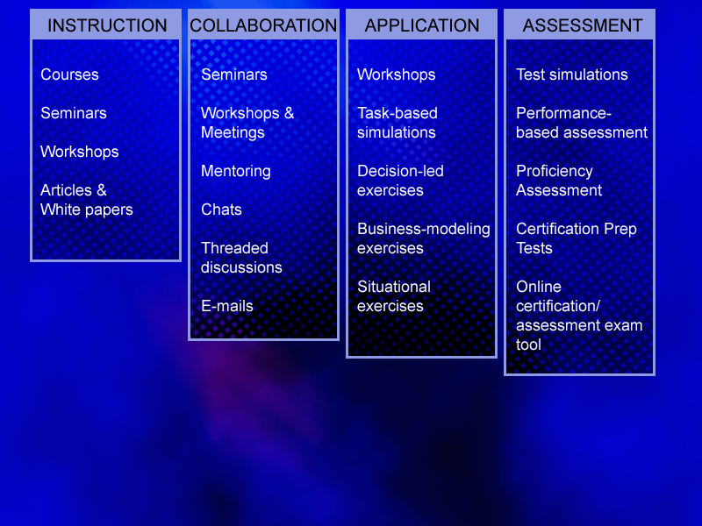

SmartForce simulations are most widely applied in the Application area, however in the future they may be a form of authentic assessment.

Role-play simulations enable students to apply knowledge or skills they have learned by solving real-life problems in realistic situations and scenarios. In the simulations, the student interacts with virtual characters and consults a wide variety of resources in order to realize a series of goals. The game-like environment of the simulation offers an enjoyable and challenging way in which to learn.

Role-play simulations are used to teach a variety of people-oriented subjects, including sales, customer relationship management, e-commerce, and leadership. The simulations themselves will also vary to suit the learning objective. For example, some role-play simulations recreate situations where students adopt the role of
"project manager" in a virtual organization. To succeed, the student performs all the tasks necessary to see a project through to completion. These simulations offer a high level of life-like personal interactivity via a cast of characters —productive and unproductive team members, sales people, bosses—with whom the student must
interact in order to progress.

To assist the student in their task, role-play simulations contain a wealth of supporting material. This information can include white papers, PowerPoint presentations, links to third-party web sites, email advice from virtual managers and advisors, explanations of concepts, and “best practice" guidelines. In some cases,
background information is also available in the form of an online knowledge repository called SAGE. The learner’s performance in the simulation is tracked and comprehensive feedback is provided to help them improve their skills.

Role-play simulations are ideal in situations where human interaction is a key component of the material being learned. As a result, they frequently appear in interpersonal skills and business learning paths.

- Blooms Taxonomy - - Reference: http://ivc.uidaho.edu/mod/models/bloom/ Copyright © 1998, Dr. Terry Armstrong and Idaho Virtual Campus

Competence | Skills Demonstrated
Knowledge (MEMORIZATION) | Knowledge is defined as the remembering of previously learned material. This may involve the recall of a wide range of material, from specific facts to complete theories, but all that is required is the bringing to mind of the appropriate information. Knowledge represents the lowest level of learning outcomes in the cognitive domain.
Comprehension  (UNDERSTANDING) | Comprehension is defined as the ability to grasp the meaning of material. This may be shown by translating material from one form to another (words to numbers), by interpreting material (explaining or summarizing), and by estimating future trends (predicting consequences or effects). These learning outcomes go one step beyond the simple remembering of material, and represent the lowest level of understanding
Application  (USING) | Application refers to the ability to use learned material in new and concrete situations. This may include the application of such things as rules, methods, concepts, principles, laws and theories. Learning outcomes in this area require a higher level of understanding than those under comprehension.
Analysis  (TAKING APART) | Analysis refers to the ability to break down material into its component parts so that its organizational structure may be understood. This may include the identification of the parts, analysis of the relationships between parts, and recognition of the organizational principles involved. Learning outcomes here represent a higher intellectual level than comprehension and application because they require an understanding of both the content and the structural form of the material
Synthesis  (PUTTING TOGETHER) | Synthesis refers to the ability to put parts together to form a new whole. This may involve the production of a unique communication (theme or speech), a plan of operations (research proposal), or a set of abstract relations (scheme for classifying information). Learning outcomes in this area stress creative behaviors, with major emphasis on the formulation of new patterns or structures.
Evaluation  (JUDGING) | Evaluation is concerned with the ability to judge the value of material (statement, novel, poem, research report) for a given purpose. The judgments are to be based on definite criteria. These may be internal criteria (organization) or external criteria (relevance to the purpose) and the student may determine the criteria or be given them. Learning outcomes in this area are highest in the cognitive hierarchy because they contain elements of all of the other categories, plus conscious value judgments based on clearly defined criteria.

The simulations are geared to higher-order and conceptual learning.
With this approach we hope to achieve the following:
10
20
30
50
85
90
Simulation
High Level Skills
High Rate of
Retention
0
20
40
60
80
100
Reading
Lecture
Illustration
Multimedia
Learning by Doing
Teaching & Doing
% Retention
Synthesis
Analysis
Application
Comprehension
Knowledge
Evaluation
Simulation
We achieve these high retention rates by making each of our simulations meet the following learning principles -- Malcolm Youngren, SmartForce

- Experiential - Role-play simulations allow the Learner to "Learn by Doing" as opposed to by reading or listening. This type of learning is more engaging. (Instead of listening or reading about it, the Learner DOES IT)

- Causal - Learners must see the impact of a decision to understand the decision - (CASE BASED REASONING - expectation failure/success + explanation). One of the ironies of learning is that we learn best by failing. A good learning environment must allow (almost encourage) a person to fail, show the results, and provide feedback on how to do the task better next time. (If people were to retake simulation and make different choices, outcomes are likely to be different - - therefore the simulation is reusable)

- Context Rich - The learning environment must look like work, feel like work, respond like work, and have all the nuances and subtleties of work -- this way the Learner can transfer (accommodate) what they have learned to their own workplace. (Real audio and real-life characters, email, documents, Internet, phones, etc.)

- Personal - All learners are different and people learn in different ways and approach a learning opportunity in varying degrees of expertise. Our simulations offer many different paths and modes (aural, visual, textual) to meet these needs. (Use choose your own adventure books as metaphor - Learner has many statements to choose from)

- Reflective - By giving the learner an opportunity to learn in a risk-free environment, not only is the learner learning another way to learn, they are thinking about ways to improve while doing it. (There are no consequences to a Learner's actions - the learning takes prior experiences and molds new experiences to aid in retention of learning)

- Social - Discussion and debate is essential to learning and ownership of ideas, knowledge, and skills. Both provide exploration into other people's viewpoints and perspectives. (Many times a Learner needs to present ideas, make decisions, and they do this through social interaction; we also have war stories which help demonstrate a process or a tell a real life scenario)

